Swedish Thrash Metal force reveals
first single and lyric video for
"Through The Eyes Of The Ancient Gods"
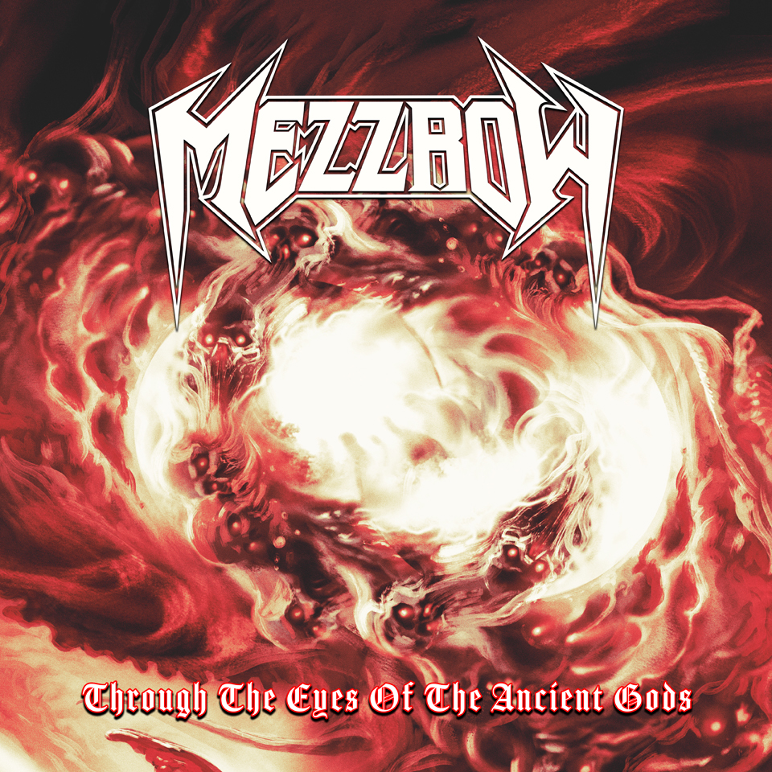

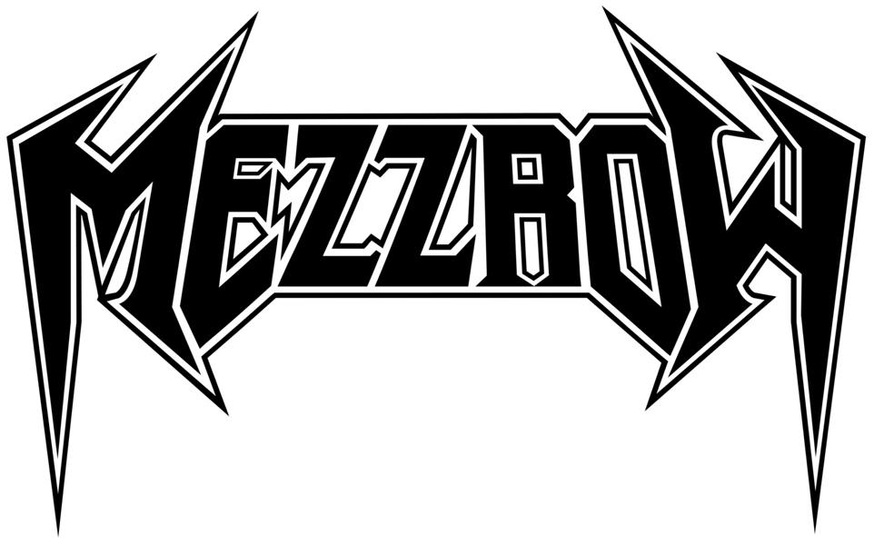
MEZZROW are back after 30 years! The Swedish Thrash Metal force will release their second and new studio album "Summon Thy Demons" on April 21th on their new label Fireflash Records.

Today the band reveals their first single and a lyric video for the track "Through The Eyes Of The Ancient Gods". "Definitely one of the most aggressive songs on the album! Rewritten a couple of times actually, before we found the right composition. Magnus really shines here with great solos; but aren’t they all?", comments the band about the in-your-face thrash hymn.

Watch the lyric video here: https://youtu.be/R_9RKWat8bc
Stream digitally: https://lnk.to/MezzrowTTEOTAG
MEZZROW built themselves a name in the thrash metal scene during the late eighties with their critically acclaimed demo tapes, "Frozen Soul" and "Cross of Tormention". In 1990 they released their classic debut album "Then Came the Killing" through Active Records, a subsidiary of Music for Nations. The album is still today considered as one of the best, if not the best, thrash metal releases from Sweden and Scandinavia. This classic album was re-mastered together with all their demos, and released through Hammerheart Records in May 2022.

During 2021 MEZZROW rose from the ashes, when bass player Conny Welén (ex-Hexenhaus) and singer Uffe Pettersson (ex-Rosicrucian) decided to make a new mark in the thrash metal world of today and have together with new guitarists Magnus Söderman(Nightrage) and Ronnie Björnström (ex-Defiatory, ex-Aeon) written new killer songs, which have pure thrash metal top-class written all over them. ”Of course we have a bit of a new and updated sound, more mature and dark, but it’s still old school thrash metal from the Bay Area that lays the foundation. We refuse to downtune the guitars and you can definitely hear what Uffe sings! Some of the songs are actually a bit melodic, but in a thrashy kind of way. So don’t worry, we don’t do any ballads”, comments Conny Welén. The line-up was completed by excellent drummer Jon Skäre (Defiatory, Hulkoff) and the band is currently laying the finishing touches on the recordings, which will be released in on April 21st, 2023 on Fireflash Records.
"Summon Thy Demons" was produced by Conny Welén, Ronnie Björnström and Magnus Söderman. The excellent mixing and mastering were done by sound wizard Ronnie Björnström (Sorcerer, Meshuggah, 220 Volt a.o.). The artwork for the cover must of course suit the music and therefore it was handled by the great Pär Olofsson who, among tons of other cool covers, recently did the cover for Exodus latest release "Persona Non Grata". Things fell into place, and the time is right for MEZZROW to leave another exclamation mark on the metal map.

MEZZROW online:
http://www.mezzrow.black/
https://www.facebook.com/mezzrowsweden/
https://www.instagram.com/mezzrowswedishthrash/
https://www.youtube.com/user/Mezzrowsweden
https://open.spotify.com/artist/68BIW54I3T7WCjot9WOK4Z

